Administrator Manual

Iloilo Top Property Homes (ITPH)
Introduction
The ITPH Administrator Panel is designed to help administrators efficiently manage the Iloilo Top Property Homes website. Through the admin panel, administrators can oversee property listings, reservations, customer accounts, agents, blogs, vlogs, inquiries, and other system information. The system provides a secure and organized environment to ensure smooth daily operations.

1. Administrator Login
Purpose
The Login page allows authorized administrators to access the administrator dashboard.
Steps
- Open the ITPH Administrator Login page.
- Enter your registered email address.
- Enter your password.
- Click the Login button.
Expected Result
If the credentials are correct, the administrator is redirected to the Dashboard.

Figure 1.1 Administrator Login Page
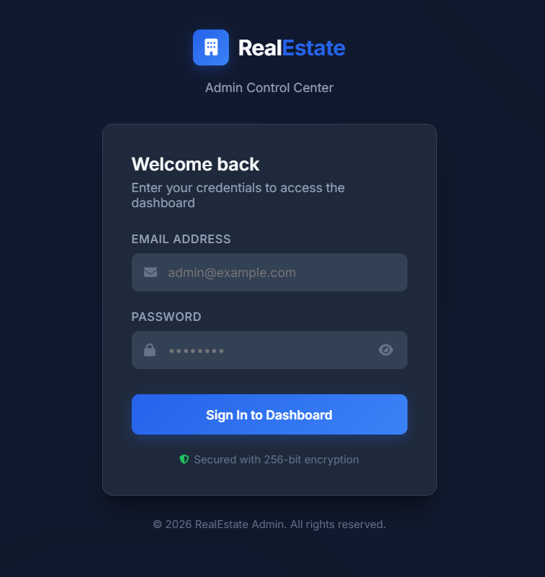

Dashboard
Purpose
The Dashboard provides an overview of the entire system by displaying important statistics and recent activities.
Dashboard Features
- Total Properties
- Total Registered Users
- Total Reservations
- Total Blogs/Vlogs
- Online Customers
- Online Agents
- Online Administrators
- Recent Reservations
- Notifications
- Contact Messages
- Reservation Analytics Charts
Expected Result
The administrator can quickly monitor the current status of the system.
Figure 2.1 Dashboard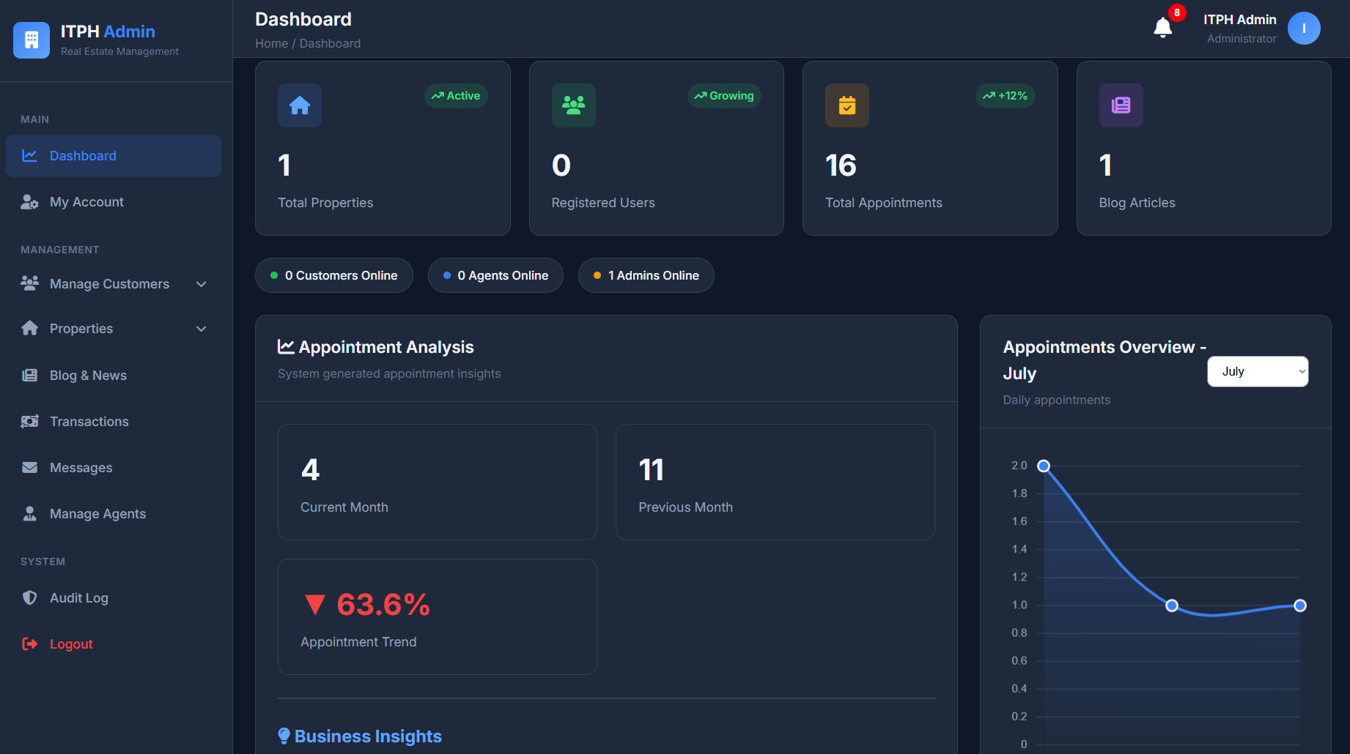

Property Management
Purpose
The Property Management module allows administrators to manage all property listings displayed on the website.
Functions
- Add new property
- Update property information
- Delete property
- Upload property images
- View property details
Steps
- Open Property Management.
- Click Add Property.
- Fill in the required information.
- Upload property images.
- Click Save.
Expected Result
The property is successfully added and displayed on the website.
Figure 3.1 Property Management
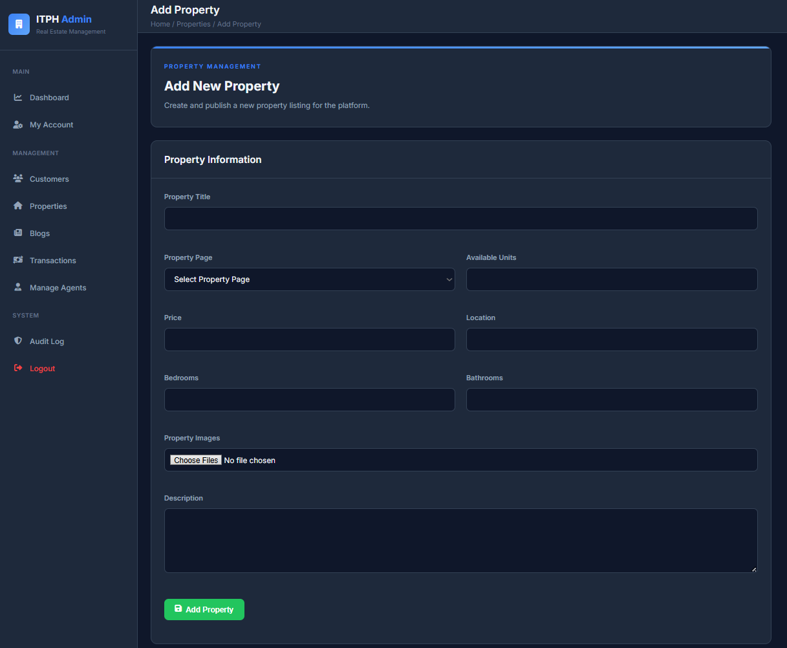

Reservation History
Purpose
Reservation History stores all customer reservation records.
Functions
- View reservation details
- Monitor reservation status
- Check payment information
Expected Result
Administrators can review all reservation transactions.
Figure 4.1 Reservation History
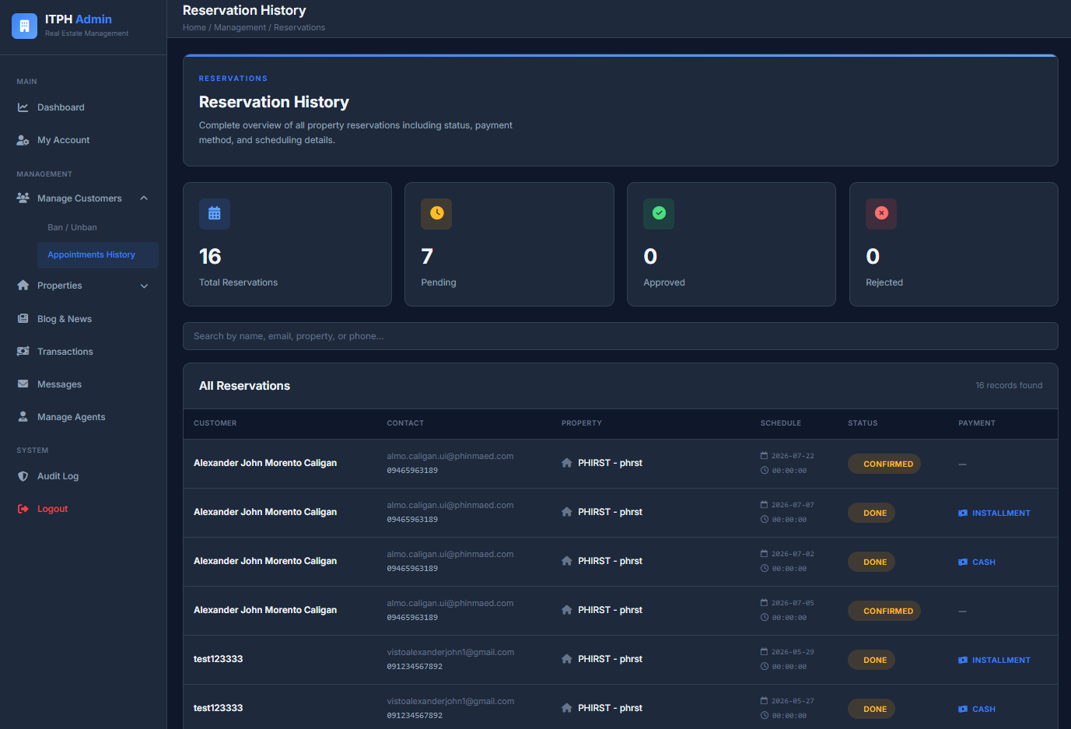
Customer Management
Purpose
This module allows administrators to manage customer accounts.
Functions
- View customer list
- Ban customer
- Unban customer
- Monitor customer status
Steps
- Open Customer Management.
- Select a customer.
- Click Ban or Unban.
Expected Result
The customer's account status is updated successfully.
Figure 5.1 Customer Management
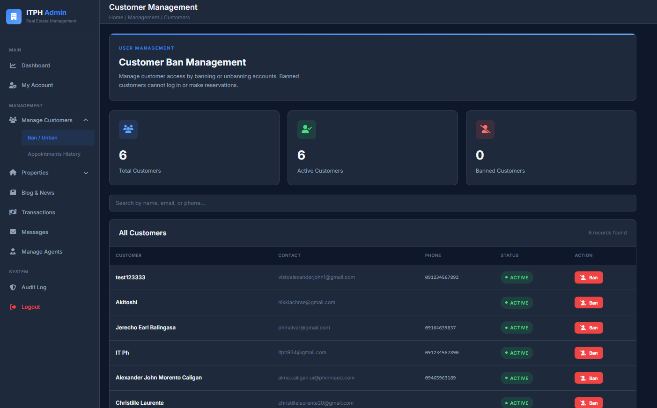
Agent Management
Purpose
The Agent Management module is used to manage real estate agents.
Functions
- Add new agent
- Activate or deactivate agents
- Reset login attempts
- Delete agent accounts
Steps
- Open Manage Agents.
- Click Add Agent.
- Enter the required information.
- Click Save.
Expected Result
The new agent account is added successfully.
Figure 6.1 Agent Management
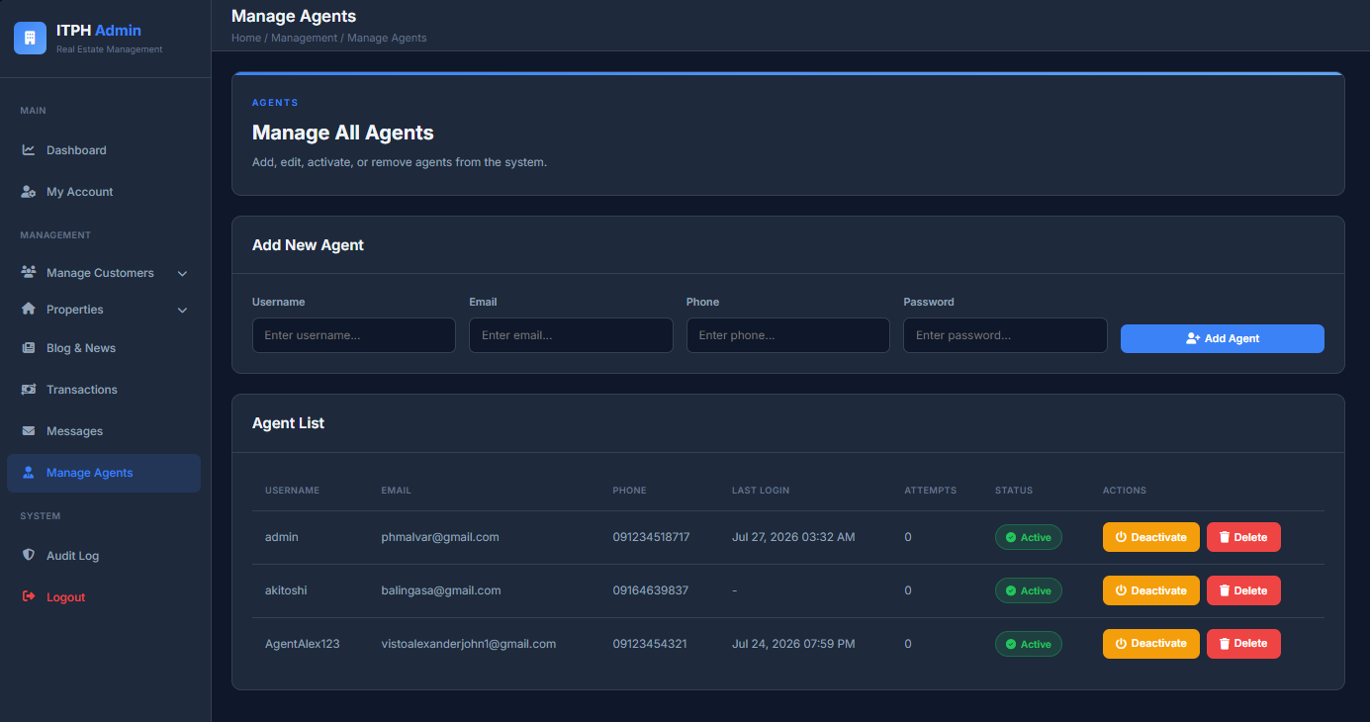

News and Vlog Management
Purpose
This module allows administrators to publish and manage news articles and promotional vlogs.
Functions
- Create news articles
- Edit news
- Delete news
- Upload vlogs
- Delete vlogs
- Publish or unpublish content
Steps
- Open News & Vlogs.
- Select the desired tab.
- Add or edit the content.
- Click Save.
Expected Result
The news article or vlog is successfully published on the website.

Figure 7.1 News and Vlog Management
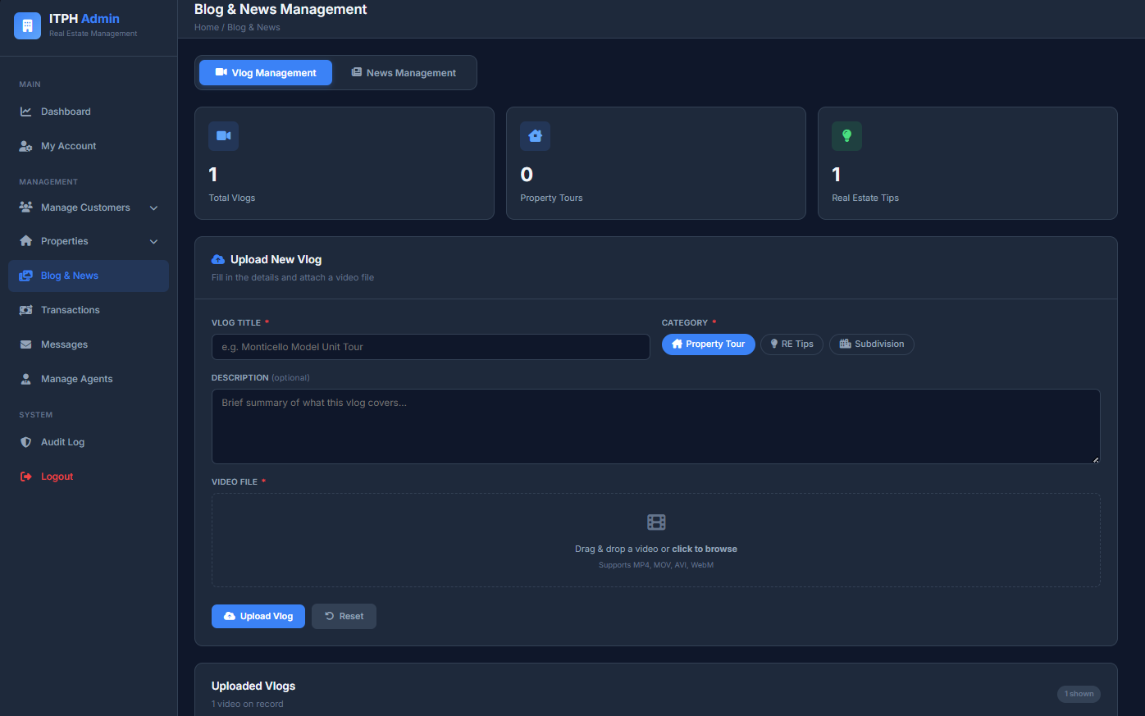
Contact Messages
Purpose
The Contact Messages module displays inquiries submitted by website visitors.
Functions
- View customer inquiries
- Read messages
- Monitor communication requests
Expected Result
Administrators can review customer inquiries and respond through appropriate communication channels.

Figure 8.1 Contact Messages
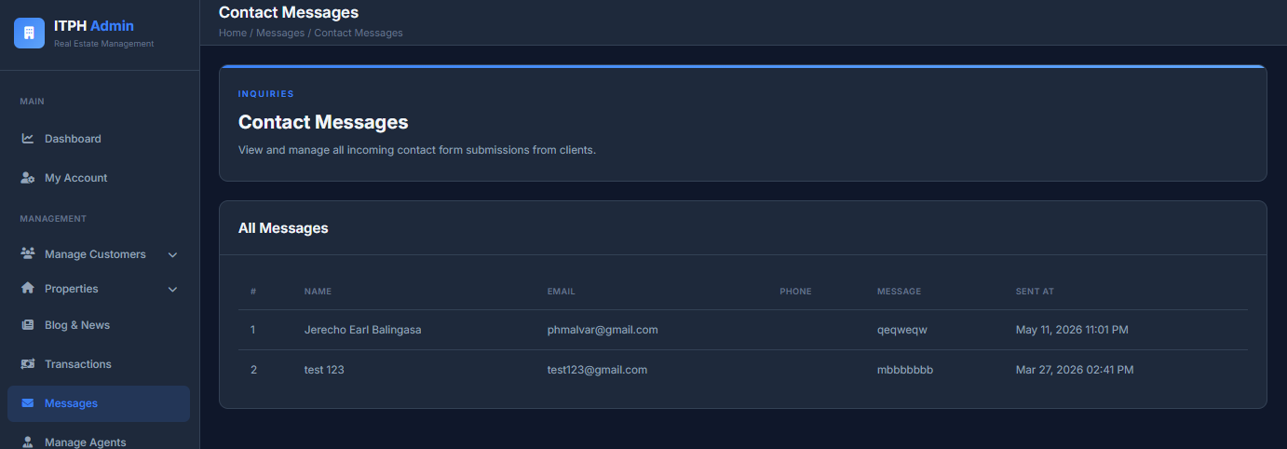
Audit Logs
Purpose
Audit Logs record administrator and user activities within the system.
Functions
- View authentication logs
- View transaction logs
- Search records
- Filter activities
- Monitor online users
Expected Result
The administrator can monitor system activities and login history.

Figure 9.1 Audit Logs
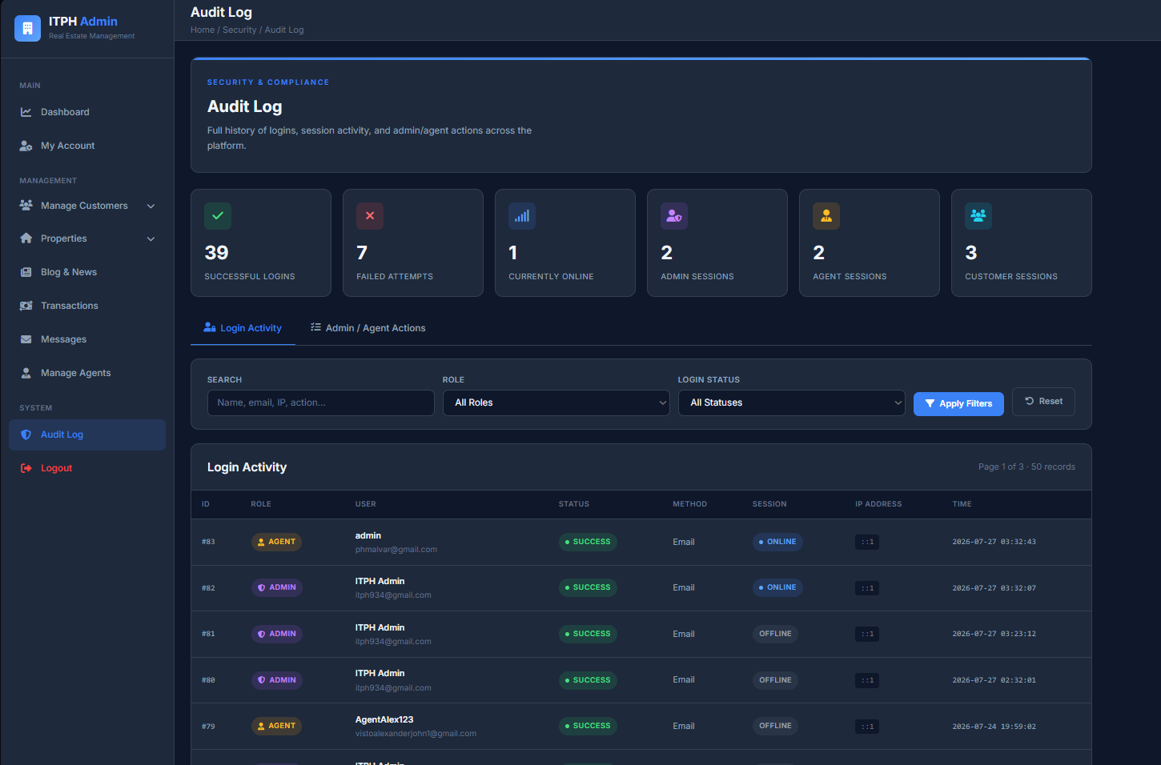
My Account
Purpose
The My Account page allows administrators to manage their personal account information.
Functions
- Update username
- Update email address
- Change password

Steps
- Open My Account.
- Edit the desired information.
- Click Update.
Expected Result
The administrator’s account information is successfully updated.
Figure 10.1 My Account
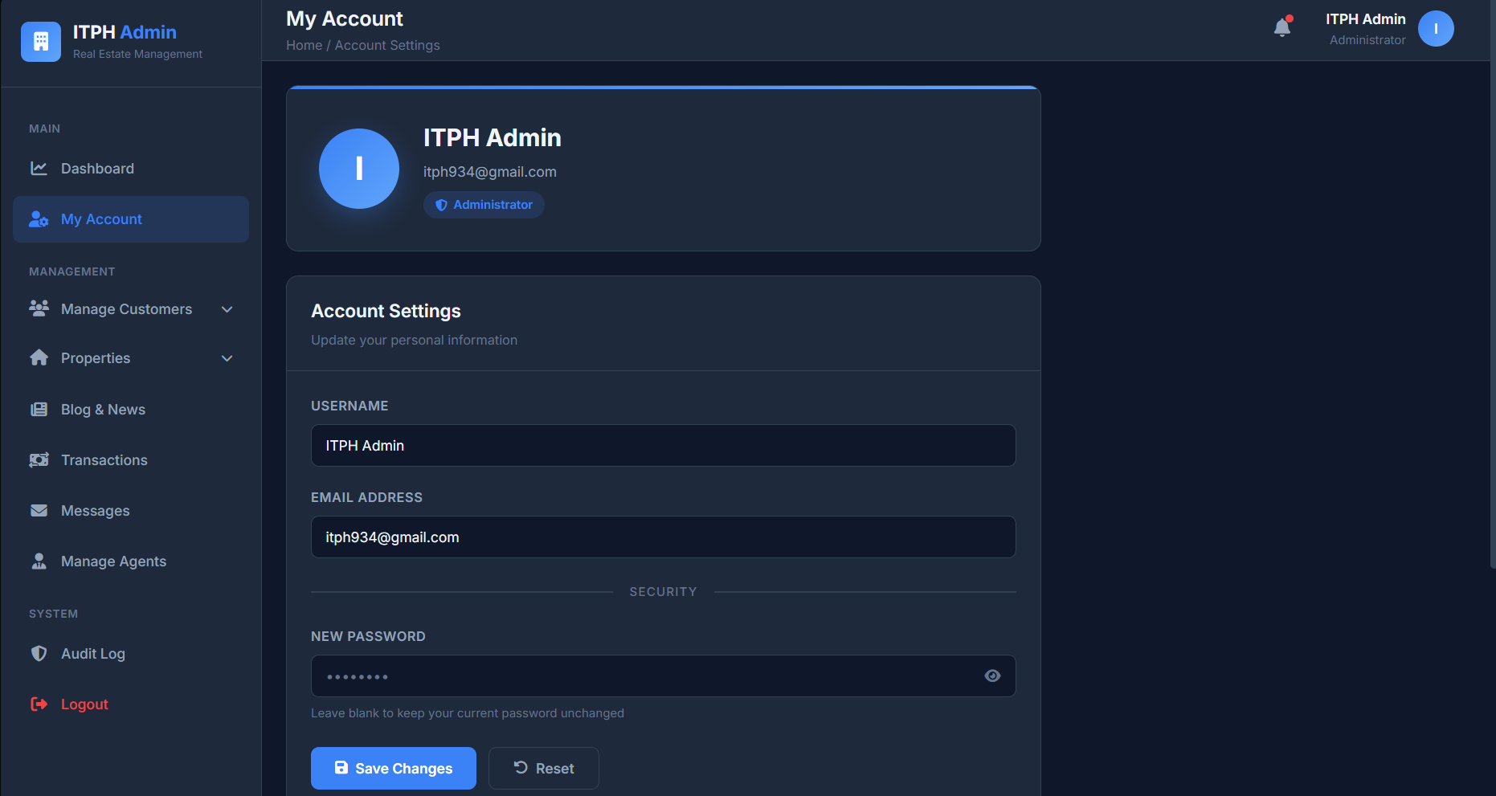
Logout
Purpose
The Logout function securely ends the administrator’s session.
Steps
- Side bar under Audit Log.
- Select Logout.
Expected Result
The current session is terminated, and the administrator is redirected to the login page.
Figure 1.1 Logout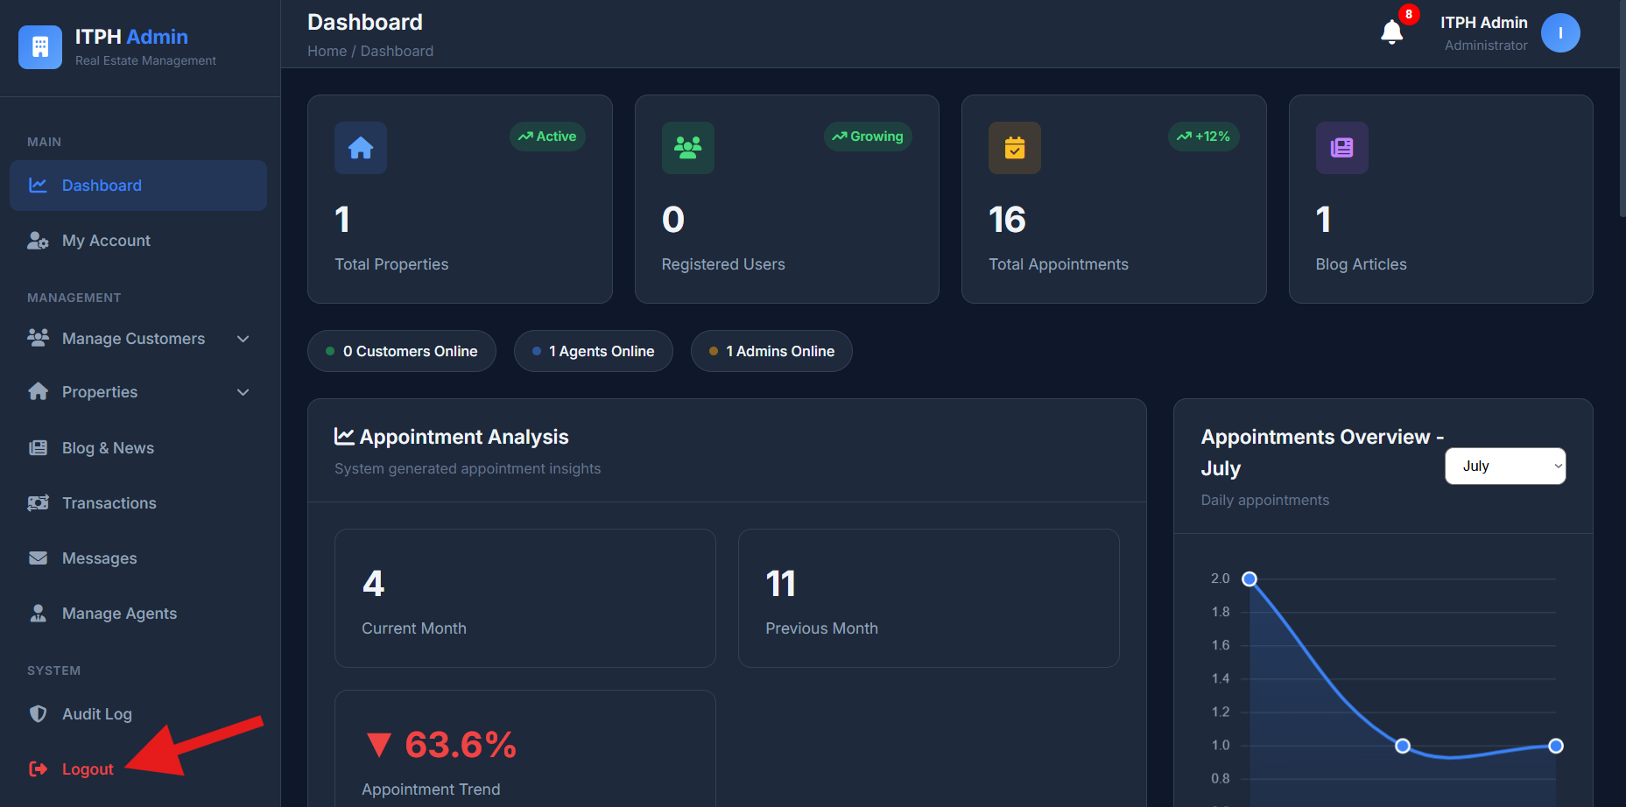

Security Features
The ITPH Administrator Panel includes several security measures to protect the system and user information.
- Secure administrator authentication
- Password encryption using hashing
- Session management
- Protected administrator pages
- Input validation
- Activity logging
- Security headers to help protect against common web attacks

Troubleshooting

Issue | Solution
Unable to login | Verify the registered email and password.
Dashboard not loading | Check the internet connection and refresh the page.
Changes are not saved | Ensure all required fields are completed before saving.
Images are not uploaded | Verify the file format and upload again.
Unable to access a module | Make sure you are logged in with an administrator account.

Conclusion
The ITPH Administrator Panel provides administrators with the necessary tools to efficiently manage properties, customer reservations, agents, news, vlogs, customer inquiries, and system activities. By following this manual, administrators can perform their responsibilities effectively while maintaining the security and reliability of the Iloilo Top Property Homes system.

